Ambalika Katoch

BI Project Assignment

Part I: Case Situation

Section 1:

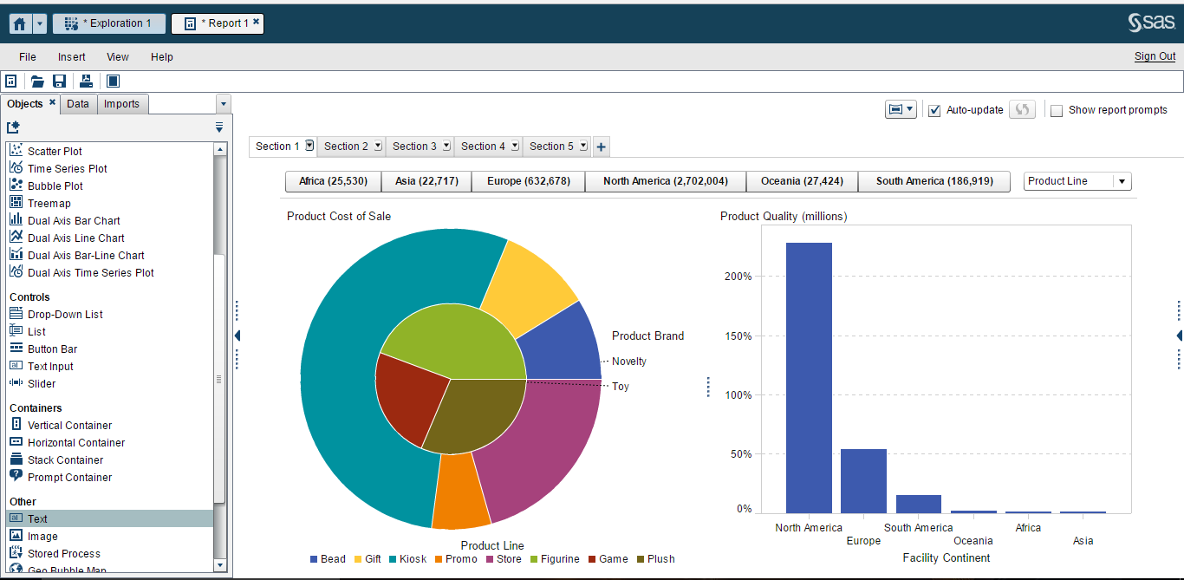

Section 2:

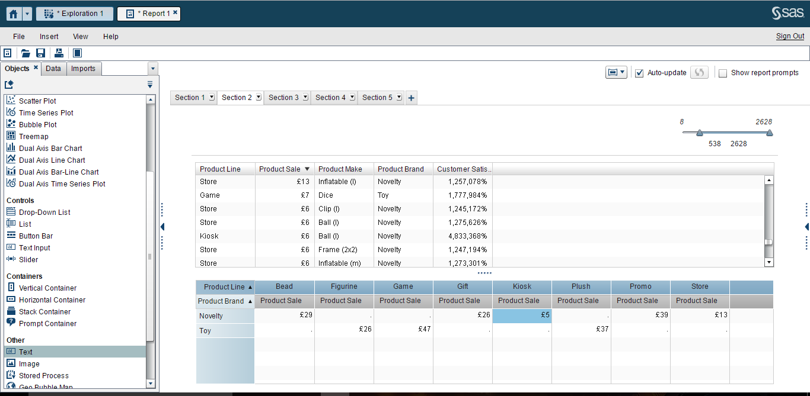

Section 3:

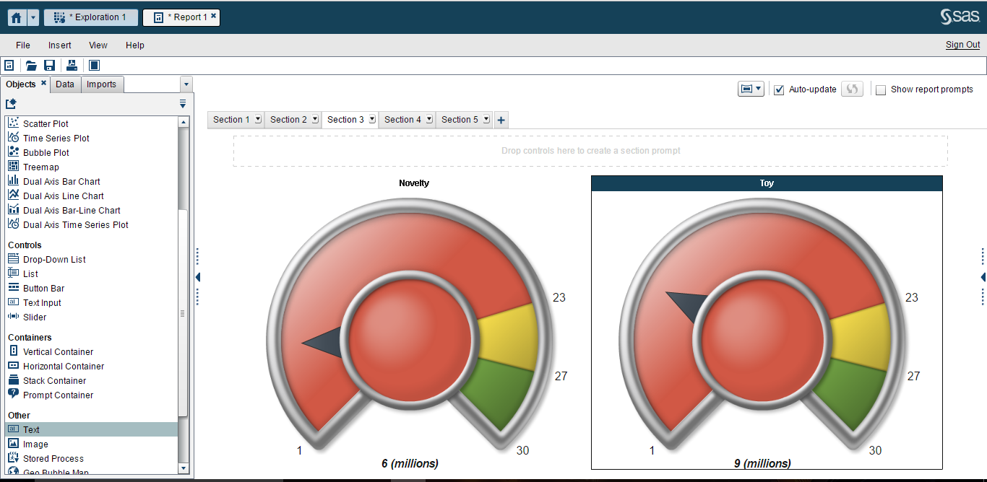

Section 4:

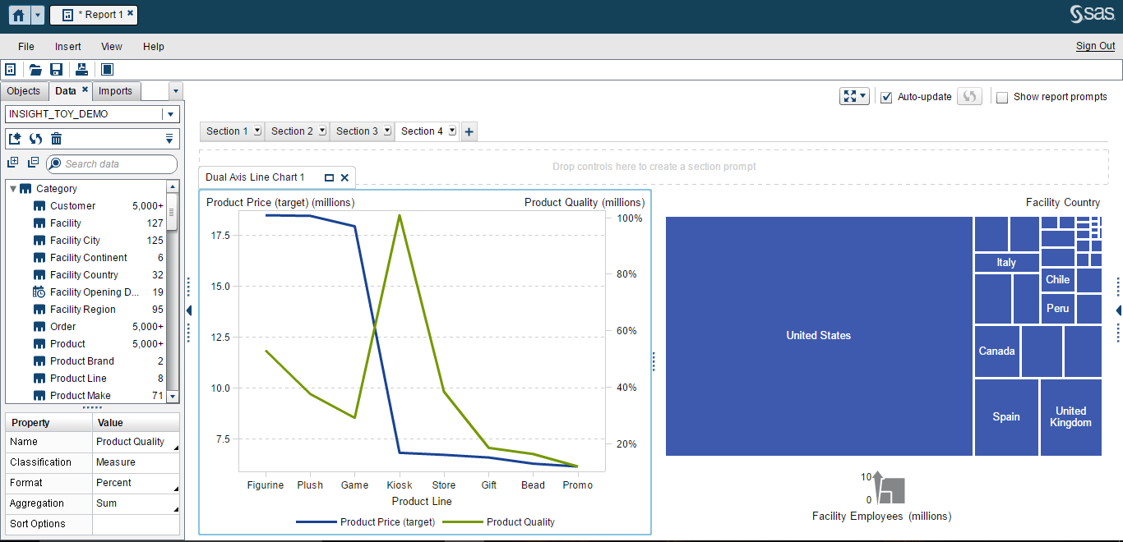

Section 5:

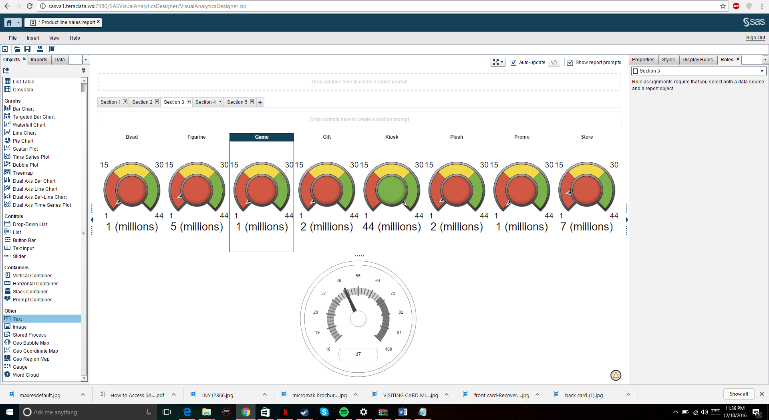

Section 6:



Part II: Using Data Visualization for Problem Solving

H1: The weight and cholesterol levels are highly correlated

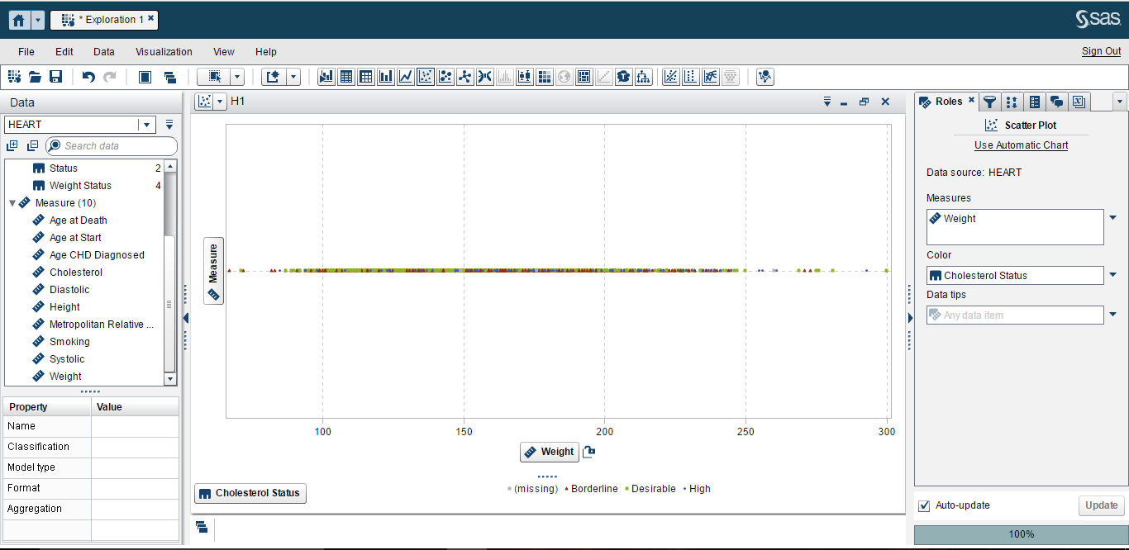

The hypothesis made in the above graph, states that the weight and cholesterol levels are highly correlated, is **true**.

As seen in the above scatter plot graph, the weight and cholesterol levels have a linear representation i.e., it shows the exact correlation between the weight of the entire set of people with their cholesterol levels.

H2: Men are usually more obese than women

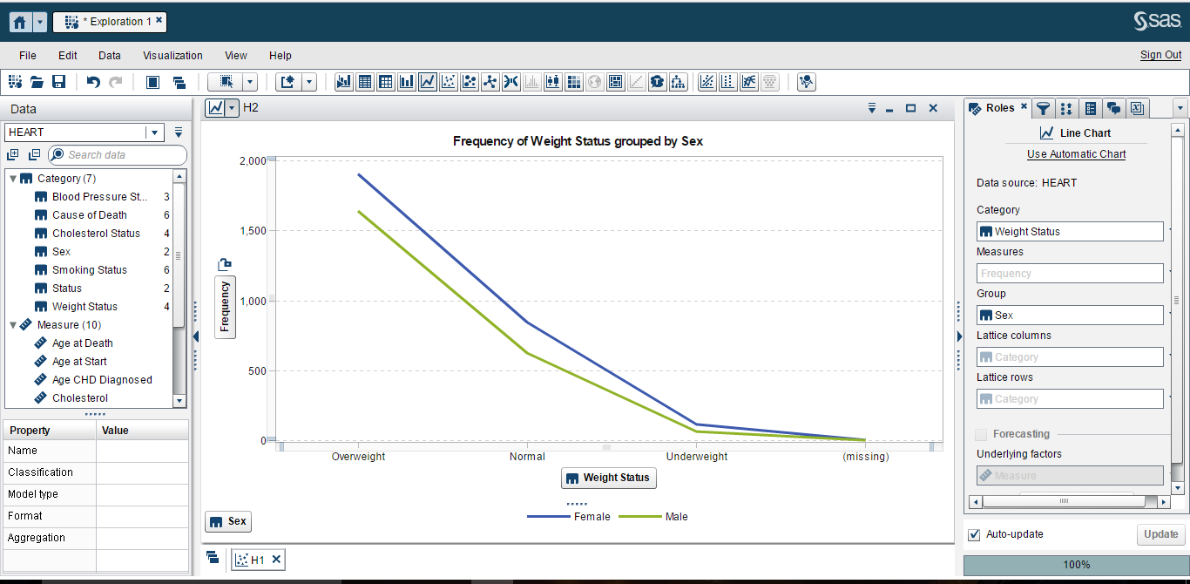

The hypothesis made in the above graph, states that men are usually more obese that women, is **false**.

As seen in the above line chart graph, men shown (green line) lie below female (blue line) and hence female have a higher frequency of weight as compared to men.

H3: Women usually smoke less than men, but their cholesterol level is much higher

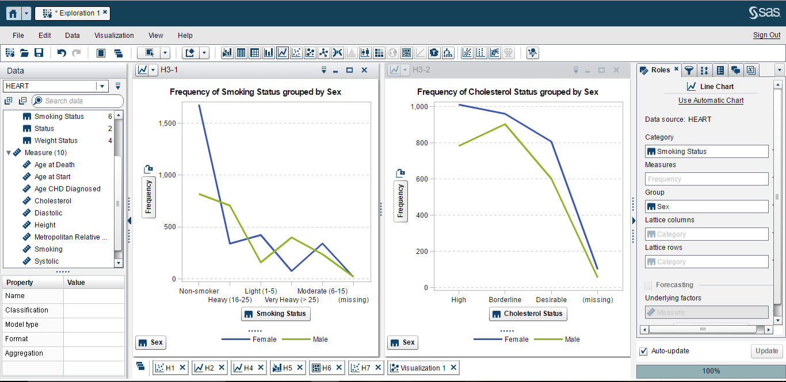

The hypothesis made in the above graph, states that women usually smoke less than men, but their cholesterol level is much higher, is **true**.

As seen in the above line graphs, first shows the frequency of smoking among men and women and the result is that women smoke less than men. In the second case, it shows that women have the high frequency of cholesterol in general. Hence proving that women usually smoke less than men and their cholesterol level is much higher as compared to men.

H4: The blood pressure is higher for people with higher cholesterol levels

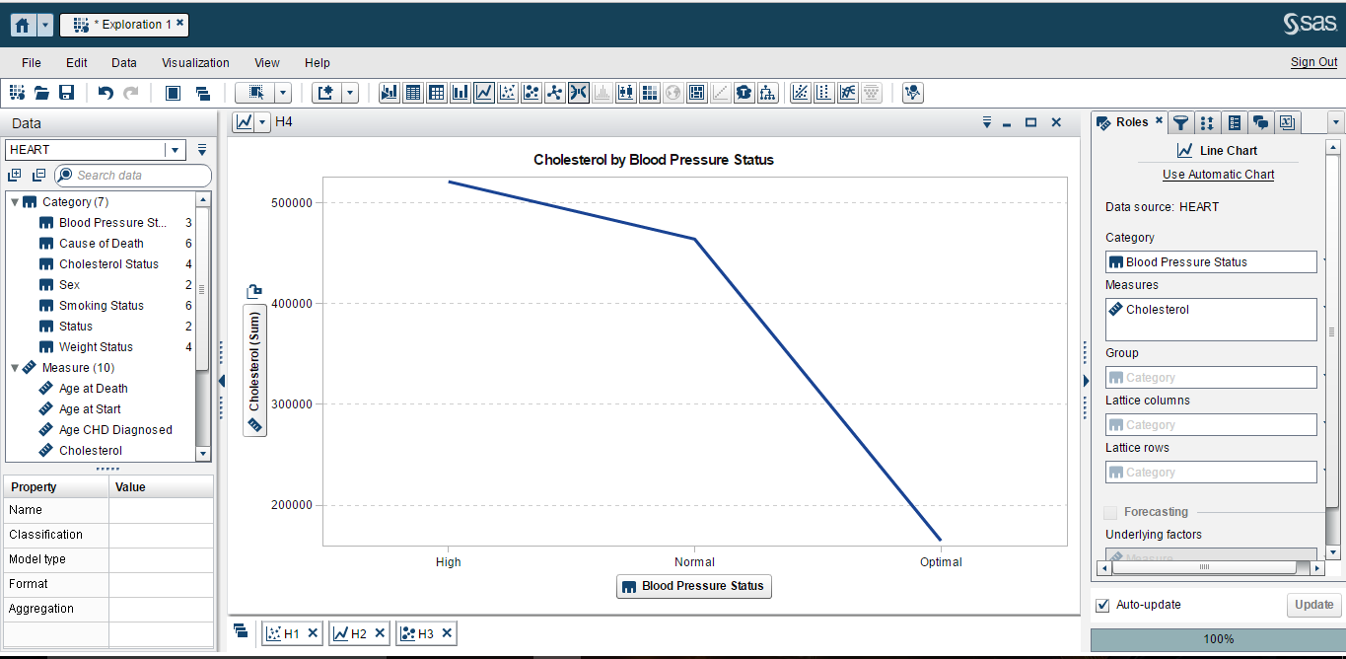

The hypothesis made in the above graph, states that blood pressure is higher for people with higher cholesterol levels, is **true**.

As seen in the above line chart, the blood pressure shows high for people who have high cholesterol, normal for people with normal cholesterol and optimal blood pressure for people with low cholesterol.

H5: Heavy smokers tend to die faster than moderate and non-smoker

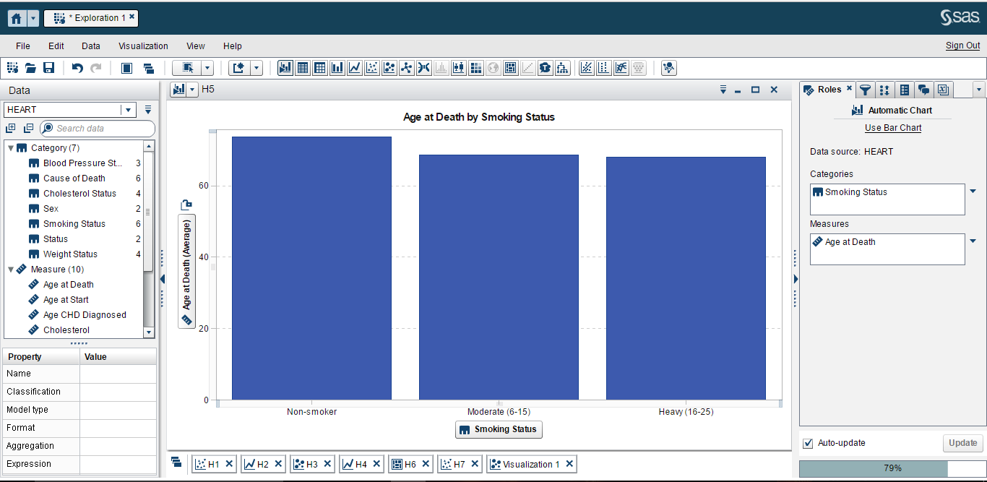

The hypothesis made in the above graph, states that heavy smokers tend to die faster than moderate non-smoker, is **true**.

As seen in the above bar chart, on an average, non-smokers live longer as compared to moderate and heavy smokers, hence heavy smokers die faster .

H6: Most non-smokers are overweight

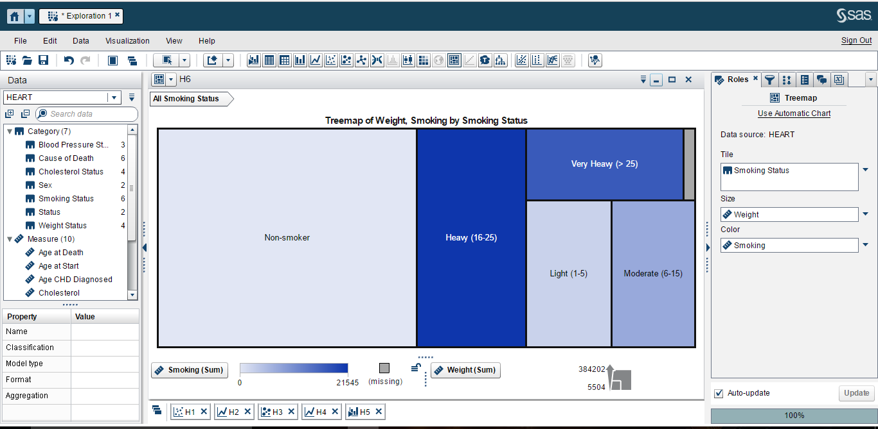

The hypothesis made in the above graph, states that most non-smokers are overweight, is **true**.

As seen in the above tree map, size is determined by the weight and non-smokers have the largest size and hence they are heavier as compared to other group of smokers.

H7: Correlation between weight and height is higher in men than in women

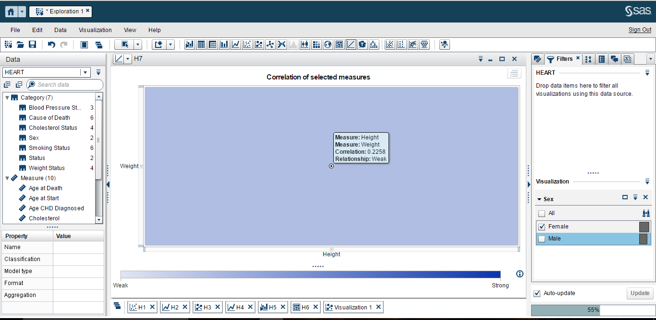a

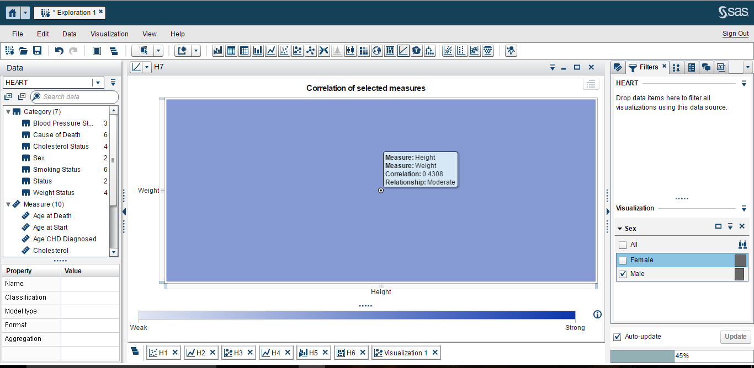

The hypothesis made in the above graph, states that most non-smokers are overweight, is **true**.

As seen in the above correlation graphs between weight and height among men and women, the correlation in female is weaker and correlation in men is stronger.

CHD: Distinctive characteristics for people who suffered from coronary heart disease

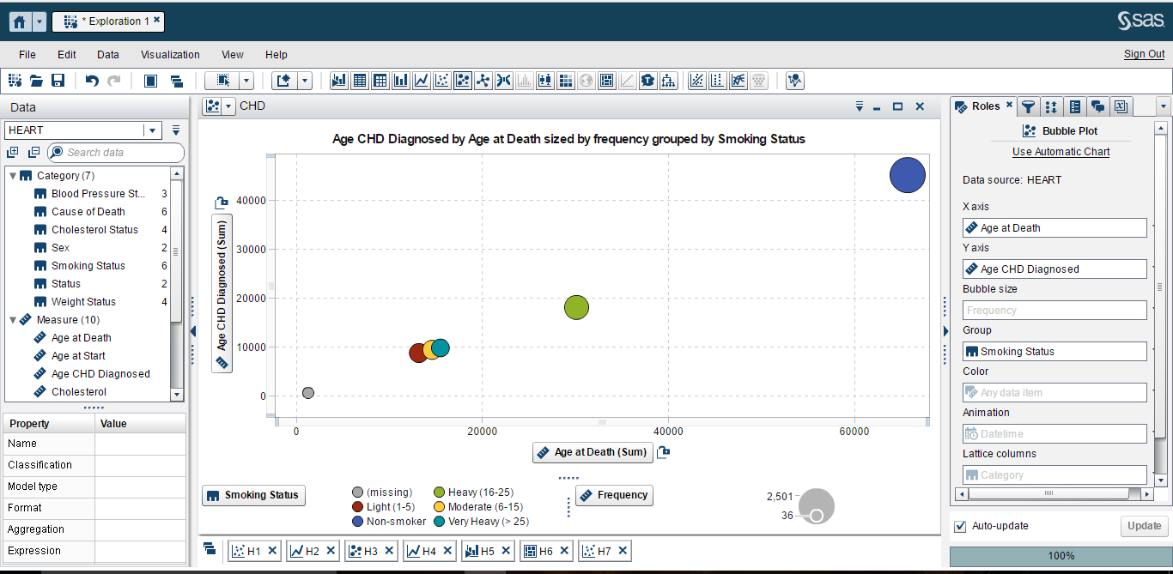

As shown is the bubble plot graph, people who are non-smokers die late as compared to very smokers or moderate smokers. The age CHD diagnoses for non-smoker is high as compared to other smokers.

The blue color represents the non-smokers, yellow represents moderate smokers, green represents heavy smokers and red represents light smokers.